FootPrint Project Specification

## The Team

Yikun Zhou: yikunz

Jiaoying Mu: jiaoyinm

Fanghan Lei: flei

Sherry Liu: shiyil  *=> Product Owner of the First Sprint*

## Product Backlog

|  |  |  |  |  |  |
| --- | --- | --- | --- | --- | --- |
| **Sprint** | **Group** | **Item** | **Description** | **Prioritization** | **Estimated Hrs** |
| 1 | Map related | Introducing Google Map API | Display on the main page with Google map functionalities | High | 40 |
| 1 | Map related | Pin Drop | Add pin on the map and open a log editor | High | 20 |
| 2 | Travel log related | Log Editor | Create/read/update and delete travel logs/planners | High | 20 |
| 2 | Travel log related | Login Page | Filter/sort travellogs by geographical location, date, etc respectively | Medium | 15 |
| 2 | Social related | Login and Register | Authentication/registration (Oauth) | High | 10 |
| 2 | Social related | Share, Like, @, Bookmark | Share/like/@/bookmark functionalities to tag other users the user travelled with/ will travel with | High | 15 |
| 3 | Social & Travel log | Log Collaboration | Allow users to collaborate on a travel log just like a Google Doc | Medium | 20 |
| 3 | Social related | Chat | Allow users to send direct private message to each other | Low | 20 |

Please see in the github team repository folder the excel file.

## First Sprint Backlog

Below is the screen shot and a link to Trello for us to keep a record of the Sprint backlog.

https://trello.com/invite/b/2CBIr4Wf/efa6bc4e546d8634220e802c8ec5c72b/footprint

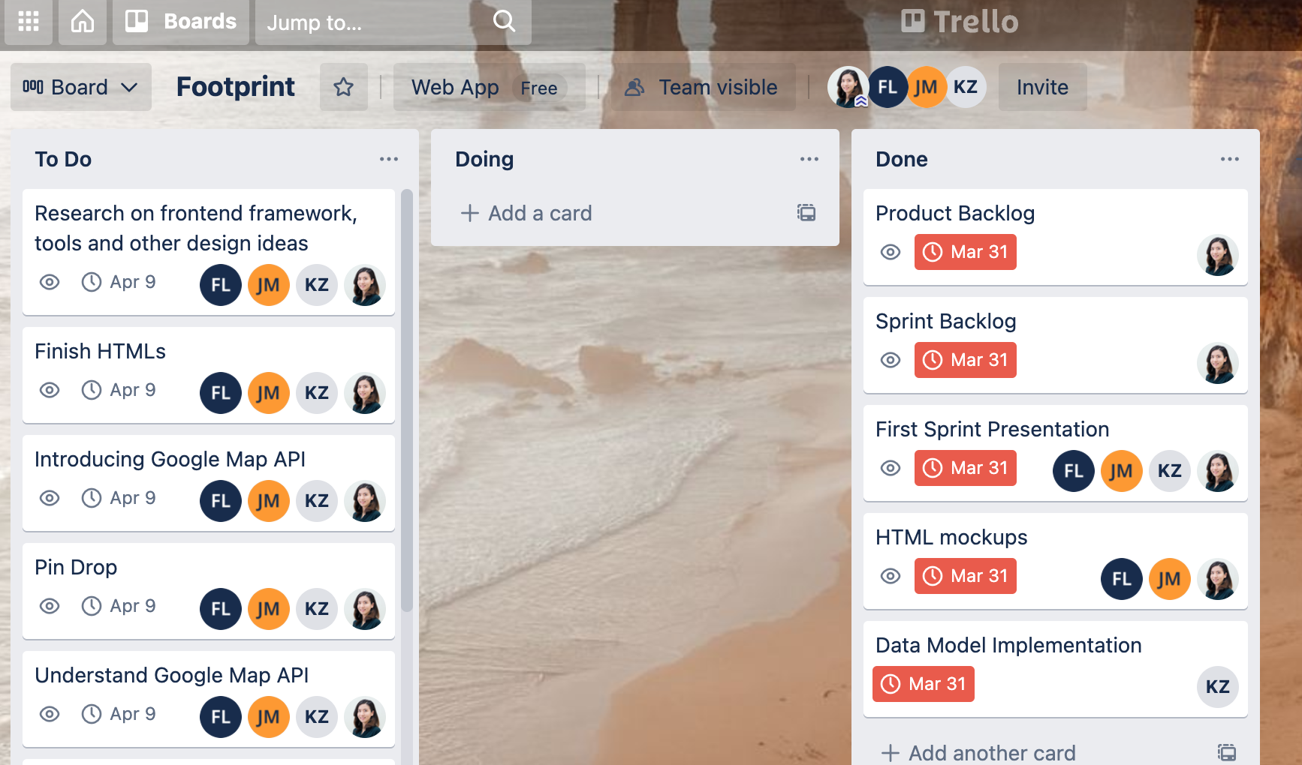

## Implementation of the Data Models

Please see in the github team repository folder the Django Model file.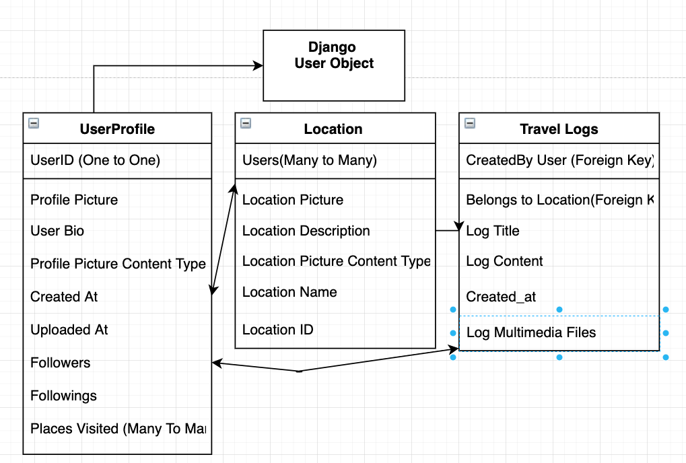

## HTML Mockups

Please see below the interactive HTML Mockups. The user could click on the Map to add a pin and open the log editor to add a travel log/planner. Some discovery social pages including timeline, people, and spots are also included.

https://run.mockplus.com/CWrvxY2xVGCfmRsdEdsN/index.html